**Chapter 2**

**Vectors in Space**

**2.5 Equations of Lines and Planes in Space**

**Section Exercises**

**In the following exercises, points  and  are given. Let  be the line passing through points  and .**

1. **Find the vector equation of line **
2. **Find parametric equations of line **
3. **Find symmetric equations of line **
4. **Find parametric equations of the line segment determined by  and **

243.  

Answer: a.   b.   c.  d.  

245.  

Answer: a.   b.   c.  d.  

**For the following exercises, point  and vector  are given. Let  be the line passing through point  with direction **

1. **Find parametric equations of line **
2. **Find symmetric equations of line **
3. **Find the intersection of the line with the plane.**

247.  

Answer: a. **  b.  c. 

249.   where  and 

Answer: a.   b.  c. The line does not intersect the plane.

**For the following exercises, line  is given.**

1. **Find point  that belongs to the line and direction vector  of the line. Express  in component form.**
2. **Find the distance from the origin to line **

251.  

Answer: a.   b. 

253. Find the distance between point  and the line of symmetric equations

Answer: 

**For the following exercises, lines  and  are given.**

1. **Verify whether lines  and  are parallel.**
2. **If the lines  and  are parallel, then find the distance between them.**

255.   

Answer: a. Parallel; b. 

257. Show that the line passing through points  and  is perpendicular to the line with equation  

Answer: This is a proof; therefore, no answer is provided.

259. Find the point of intersection of the lines of equations  and  

Answer: 

**For the following exercises, lines  and  are given. Determine whether the lines are equal, parallel but not equal, skew, or intersecting.**

261.  and 

Answer: The lines are skew.

263.   and 

Answer: The lines are equal.

265. Consider line  of symmetric equations  and point 

1. Find parametric equations for a line parallel to  that passes through point 
2. Find symmetric equations of a line skew to  and that passes through point 
3. Find symmetric equations of a line that intersects  and passes through point 

Answer: a.   b. For instance, the line passing through  with direction vector  c. For instance, the line passing through  and point  that belongs to  is a line that intersects; 

**For the following exercises, point  and vector  are given.**

1. **Find the scalar equation of the plane that passes through  and has normal vector **
2. **Find the general form of the equation of the plane that passes through  and has normal vector **

267.  

Answer: a.  b. 

269.  

Answer: a.  b. 

**For the following exercises, the equation of a plane is given.**

1. **Find normal vector  to the plane. Express  using standard unit vectors.**
2. **Find the intersections of the plane with theaxes of coordinates.**
3. **Sketch the plane.**

271. **[T]** 

Answer: a.  b.   and 

c.

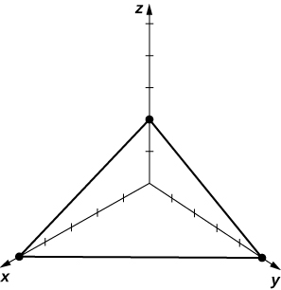

273. 

Answer: a.  b. 

c.

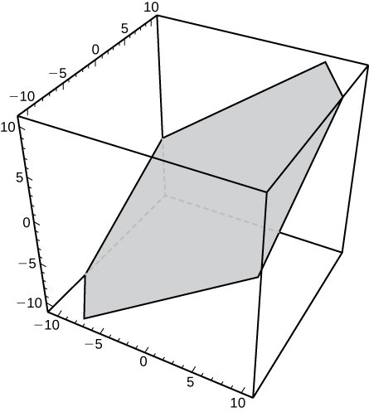

275. Given point  and vector  find point  on the axis such that  and  are orthogonal.

Answer: 

277. Find parametric equations of the line passing through point  that is perpendicular to the plane of equation 

Answer:  

279. Show that line  is parallel to plane **

Answer: This is a proof; therefore, no answer is provided.

**For the following exercises, points  are given.**

1. **Find the general equation of the plane passing through **
2. **Write the vector equation  of the plane at a., where  is an arbitrary point of the plane.**
3. **Find parametric equations of the line passing through the origin that is perpendicular to the plane passing through **

281.  and 

Answer: a.  b.  c.  

283. Consider the planes of equations  and 

1. Show that the planes intersect.
2. Find symmetric equations of the line passing through point  that is parallel to the line of intersection of the planes.

Answer: a. Answers may vary; b.

1. Find the scalar equation of the plane that passes through point  and is perpendicular to the line of intersection of planes  and 

Answer: 

287. Determine whether the line of parametric equations   intersects the plane with equation  If it does intersect, find the point of intersection.

Answer: The line intersects the plane at point 

289. Find the distance from point  to the plane of equation 

Answer: 

**For the following exercises, the equations of two planes are given.**

1. **Determine whether the planes are parallel, orthogonal, or neither.**
2. **If the planes are neither parallel nor orthogonal, then find the measure of the angle between the planes. Express the answer in degrees rounded to the nearest integer.**

291. **[T]** 

Answer: a. The planes are neither parallel nor orthogonal; b. 

293.  

Answer: a. The planes are parallel.

295. Show that the lines of equations   and  are skew, and find the distance between them.

Answer:

297.Consider point  and the plane of equation 

1. Find the radius of the sphere with center  tangent to the given plane.
2. Find point *P* of tangency.

Answer: a.  b. 

299. Two children are playing with a ball. The girl throws the ball to the boy. The ball travels in the air, curves  ft to the right, and falls  ft away from the girl (see the following figure). If the plane that contains the trajectory of the ball is perpendicular to the ground, find its equation.

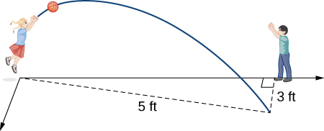

Answer: 

301. **[T]** Consider  the position vector of a particle at time  where the components of **r** are expressed in centimeters and time is measured in seconds. Let  be the position vector of the particle after  sec.

1. Determine the velocity vector  of the particle after  sec.
2. Find the scalar equation of the plane that is perpendicular to  and passes through point  This plane is called the *normal plane* to the path of the particle at point 
3. Use a CAS to visualize the path of the particle along with the velocity vector and normal plane at point .

Answer: a.  b. 

c.

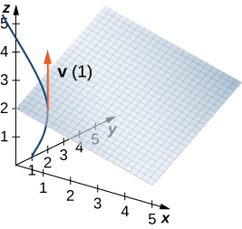

**Student Project**

**Distance between Two Skew Lines**

1. First, write down two vectors,  and  that lie along  and  respectively.

Answer: The two vectors can be found directly from the symmetric equations. They are



3. From vector  form a unit vector  in the same direction.

Answer: The unit vector is



5. The dot product of two vectors is the magnitude of the projection of one vector onto the other—that is,  where  is the angle between the vectors. Using the dot product, find the projection of vector  found in step  onto unit vector  found in step 3. This projection is perpendicular to both lines, and hence its length must be the perpendicular distance  between them. Note that the value of  may be negative, depending on your choice of vector  or the order of the cross product, so use absolute value signs around the numerator.

Answer: The distance is now the absolute value of the dot product,



7. Is your general expression valid when the lines are parallel? If not, why not? (Hint: What do you know about the value of the cross product of two parallel vectors? Where would that result show up in your expression for )

Answer: The two lines are parallel if and only if  where *s* is any constant. If we substitute, we get 0/0, which is indeterminate. Astute students may simply argue that it is not valid because the original cross product is 

If the lines are parallel, they must be in the same plane. So we form the vector  as beforeand project it onto a unit vector along either line (say ) to get the component of  along line 1 and then use the Pythagorean theorem to get the perpendicular component, which is *d*.

9. Consider the following application. Engineers at a refinery have determined they need to install support struts between many of the gas pipes to reduce damaging vibrations. To minimize cost, theyplan to install these struts at the closest points between adjacent skewed pipes. Because they have detailed schematics of the structure, they are able to determine the correct lengths of the struts needed, and hence manufacture and distribute them to the installation crews without spending valuable time making measurements.

The rectangular frame structure has the dimensions  (height, width, and depth). One sector has a pipe entering the lower corner of the standard frame unit and exiting at the diametrically opposed corner (the one farthest away at the top); call this  A second pipe enters and exits at the two different opposite lower corners; call this 

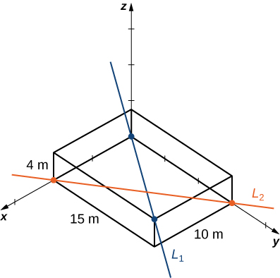

Write down the vectors along the lines representing those pipes, find the cross product between them from which to create the unit vector  define a vector that spans two points on each line, and finally determine the minimum distance between the lines. (Take the origin to be at the lower corner of the first pipe.) Similarly, you may also develop the symmetric equations for each line and substitute directly into your formula.

Answer: From the diagram, vectors along  and  are 

The unit vector from the cross product of these vectors is

 The simplest vector connecting the two lines is hence the distance is  Then we have or a better choice of (0,1,0) and we get  Using the same  we have 

This file is copyright 2016, Rice University. All Rights Reserved.